**Recipe Manager User Manual**

**Table of Contents**

**Introduction**

**Installation**

**Getting Started**

**Adding a Recipe**

**Scaling a Recipe**

**Displaying Recipe Details**

**Editing a Recipe**

**Deleting a Recipe**

**Conclusion**

**1. Introduction**

**The Recipe Manager application is designed to help you manage and scale your recipes effortlessly. With this app, you can easily add, scale, and view recipe details. This user manual will guide you through the process of using the Recipe Manager application effectively.**

**2. Installation**

**To use the Recipe Manager application, follow these steps:**

**Ensure that you have the .NET Framework 4.7 or later installed on your computer.**

**Download the Recipe Manager application installer from [link].**

**Run the installer and follow the on-screen instructions to complete the installation process.**

**3. Getting Started**

**Once the Recipe Manager application is installed, follow these steps to get started:**

**Launch the application by double-clicking the Recipe Manager icon on your desktop or finding it in the Start menu.**

**The main window of the application will appear, providing you with options to add, scale, and view recipes.**

**4. Adding a Recipe**

**To add a new recipe, follow these steps:**

**Click the "enter Recipe details" button in the main window.**

**The "enter Recipe details" window will open, allowing you to enter the recipe details.**

**Fill in the required information, such as the recipe name, ingredients, and instructions.**

**Click the "OK" button to save the recipe.**

**The new recipe will be added to the list of recipes in the main window.**

**5. Scaling a Recipe**

**To scale a recipe, follow these steps:**

**Click the "Scale Recipe" button in the main window.**

**A list of available recipes will be displayed in the "Recipe Selection" window.**

**Select the recipe you want to scale by clicking on it.**

**Click the "OK" button to proceed.**

**The "Scale Recipe" window will open, allowing you to enter the scaling factor.**

**Enter the desired scaling factor and click the "OK" button.**

**The recipe will be scaled according to the provided factor.**

**A confirmation message will appear, indicating that the recipe has been scaled successfully.**

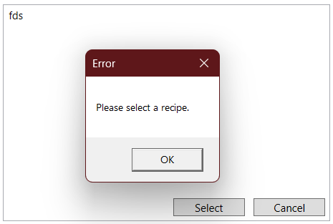

**6. Displaying Recipe Details**

**To view the details of a recipe, follow these steps:**

**Click the "Display Recipe Details" button in the main window.**

**The "Recipe Selection" window will appear, displaying a list of available recipes.**

**Select the recipe you want to view by clicking on it.**

**Click the "OK" button to proceed.**

**A message box will display the recipe details, including the name, ingredients, and instructions.**

**7. Editing a Recipe**

**To edit a recipe, follow these steps:**

**Click the "Display Recipe Details" button in the main window.**

**Select the recipe you want to edit by clicking on it.**

**Click the "OK" button to proceed.**

**The recipe details will be displayed in a message box.**

**Take note of the recipe details and close the message box.**

**Click the "Add Recipe" button in the main window to open the "Add Recipe" window.**

**Enter the updated recipe details based on the information you noted.**

**Click the "OK" button to save the changes.**

**The edited recipe will replace the previous version in the list of recipes.**

**8. Deleting a Recipe**

**To delete a recipe, follow these steps:**

**Click the "Display Recipe Details" button in the main window.**

**Select the recipe you want to delete by clicking on it.**

**Click the "OK" button to proceed.**

**The recipe details will be displayed in a message box.**

**Take note of the recipe details and close the message box.**

**Click the "Delete Recipe" button in the main window.**

**The "Delete Recipe" confirmation window will appear, displaying the details of the recipe you want to delete.**

**Click the "OK" button to confirm the deletion.**

**The selected recipe will be permanently deleted from the list of recipes.**

**Other Features**

**User can view all recipes**

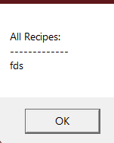

**User can delete all recipes**

**9. Conclusion**

**Congratulations! You have successfully learned how to use the Recipe Manager application to manage and scale your recipes. Enjoy organizing and cooking your favorite dishes with ease using this user-friendly app. If you have any further questions or need assistance, please refer to the application's help documentation or contact our support team at [email address].**